Based on Lecture 5(inheritance, overriding, subclasses)

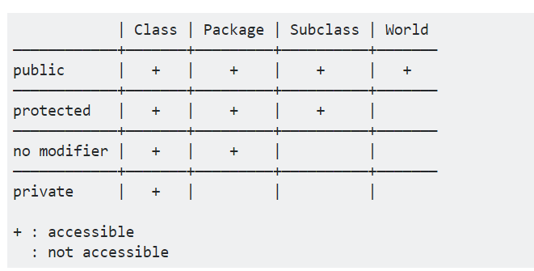

No modifier=default= int a; canbe accessed within a package.

private hides from other classes within the package.

public exposes to classes outside the package. It can be accessed from any package.

protected is a version of public restricted only to subclasses. For example you inherit the property of your father. Normally used in the subclasses

Method Overriding

Child class has the same method as of base class. In such cases child class overrides the parent class method without even touching the source code of the base class. This feature is known as method overriding.

**Rules for Method Overriding:**

1. applies only to inherited methods
2. object type (NOT reference variable type) determines which overridden method will be used at runtime
3. Overriding method can have different return type ([**refer this**](http://stackoverflow.com/questions/14694852/can-overridden-methods-differ-in-return-type))
4. Overriding method must not have more restrictive access modifier
5. Abstract methods must be overridden
6. Static and final methods cannot be overridden
7. Constructors cannot be overridden
8. It is also known as Runtime polymorphism.

**super keyword in Overriding:**

When invoking a superclass version of an overridden method the super keyword is used.  
Example:

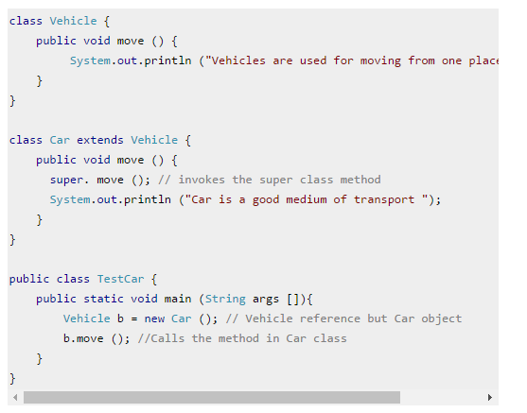

SubClass name=Car

Here you call the method move which is >*super.move*

*Then u added system.out.println*

*This is overriding.*

*See the subclass file and there u will get method printallinfo.*

Class name=vehicle

Method >move()

Method declared in the super class =CarClass

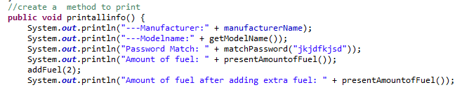

Method written in the subcarclass after overiding the superclass method

